LSA Firstball handbook

On behalf of Leeds Softball Association committee, thank you for participating in or Season Curtain raiser - LSA Firstball 2013.

We hope you have a fantastic day of softball and that the weather gods are good to us!
Whilst there is an element of competition, we aim for a good day out showcasing Softball in Leeds – play nice, people, and enjoy yourselves...

There will be various people who will have come along to talk to captains about the 2013 season, and this is a great opportunity for teams to recruit new blood. Because of where we will play, we may attract potential recruits from passers-by and park users. We ask you to therefore show the league in its best light during the Firstball event.

Two teams are playing under their own name with their own players, one team is open to a few rookies and ringers and one team is an entirely scratch team made up of league veterans and rookies. As a result, there are plenty of slots open to those new to the game and we ask your team to bring any friends, relatives, workmates, random acquaintances or otherwise potential recruits who might want to find out about Softball in Leeds.

Venue

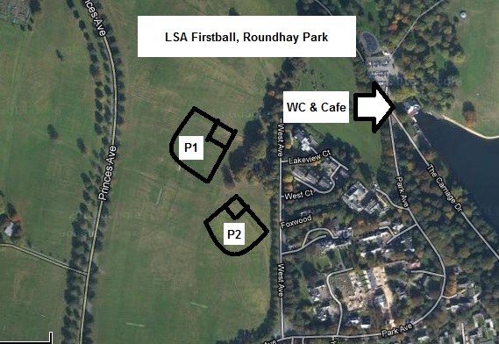

The venue for the day is Roundhay Park, next to West Avenue, and we hope that we will attract some positive interest from people in the park who might want to find a bit more about the mighty game we all love.

Please be aware that the park is a public place, and we have not charged you or paid to use the facilities. Be mindful of other park users and please be patient with any stray members of the public. In addition, please ensure that all valuables are safely stored and will not tempt casual theft.
Facilities

The nearest toilet facilities are down next to Waterloo lake, about five minutes away, and the cafe there does food and drink. There is a playground nearby for children big and small, as well as the other attractions around Roundhay Park.
Teams
Castaways, Club Dynamite, Coyotes and LSA Allstars have all entered teams.

Firstball Schedule
8:30am Registration of teams and players
9:00am LSA Allstars v Coyotes (Pitch 1), Club Dynamite v Castaways (Pitch 2)
10:30am Castaways v LSA Allstars (Pitch 1), Club Dynamite v Coyotes (Pitch 2)
11:45am Home Run Derby and recruitment session
12:30pm LSA Allstars v Club Dynamite (Pitch 1), Castaways v Coyotes (Pitch 2)
13:45pm Semi-Finals Semi final 1st v 3rd (Pitch 1), Semi final 2nd v 4th (Pitch 2)
15:00pm Cup and Plate Final Plate final (SF1W v SF2W) (Pitch 1), Cup final (SF1L v SF2L) (Pitch 2)

Home run derby

Power hitter time! Batters are pitched balls from regulation distance, and can choose which balls to hit (no ball or strike count). Each entrant will have ten hits, taken one after the other. HR will be awarded for hits beyond 200 feet, marked by fielders standing in outfield (caught balls count as HRs). A Field Umpire standing at 200 feet centre field will rule on HR.

The top five men and top five women go through to Derby final, with a further five hits, taken in turn one at a time by each batter. After five hits, if batters are tied, play through until a winner is found.

Umpires
To keep the cost to nil we’re using LSA umpires. Please remember we have some newly trained umpires behind the plate this weekend, and accept their decisions with good grace.
Protests
If there is an issue with any interpretation of a rule (not a judgement call!) then only the Captain (or, if the Captain is in the outfield, then a delegated person in the infield) may wish to raise this in a calm manner on his/her own with the umpire and, if required, the opposition captain. There will be no Protest Procedure, but feel free to discuss with any member of the committee later.
Rules
ISF Rules will be used unless stated otherwise.
Home team decided by toss of a coin, clicker, glove etc. Full Count – i.e. all batters start on 0 Balls & 0 Strikes. The time on the schedule will be the start of game time, whether the game starts on time or not (even if the umpire is delayed). If the start is delayed then the game itself will be shorter to ensure subsequent games run to time. No new innings will be called at 50 minutes. The game will:
- End if the home side is ahead – do NOT bat out
- End if the away team is batting and they then fail to go ahead by the end of their batted inning.
- Continue if the home side is batting and are behind. The game will end when the home team score the go ahead run (all runs in that at bat will score) or the away team get the 3 x outs required to end the home team’s inning before they go ahead.
Ties will count in the Round Robin phase.
In the event of a tied game in the Semi final stage then an elimination inning will take place. Both teams will get the chance to bat, with the last person to bat from the previous innings being placed on 2nd base. For this inning only, each batter will start with a 1 & 1 Count (ie 1 Ball & 1 Strike) to speed up the game. If still tied at the end of this inning you’ll have to continue in the same manner (person starting on 2nd) until a result is reached.
Points will be scored in the round robin as follows:
- 3 points for a win
- 1 point for a tie
- 0 points for a loss
If teams are tied on points at the end of the round robin stage, positions will be decided in order by:
- head-to-head results between the tied teams
- fewest runs CONCEDED against those tied teams
- fewest runs CONCEDED for all Round Robin games
- toss of a coin or, if more than 2 teams, the drawing of lots.
Each team is responsible for scoring their own team and for checking the score with the opposition after each inning.

Results should be passed to tournament control by the winning team after each game (including a Male & Female MVP chosen by opposition captain).

All Finals will still be TIMED and not 7 innings.
“Prize-giving” will be held immediately after the Cup final – at the Tournament Control Area.
First Aid
There is no First Aid provision, however, should you need emergency assistance then please dial 999 and call an ambulance. If an ambulance is not required but the person does need treatment, then they need to be taken to Leeds General Infirmary, Leeds City Centre LS1 3HE.
Kit

Bases, balls and utility gloves will be provided by the league. Please ensure that you return any equipment you borrow on the day.

Finally

Have a great day and please feedback any comments to the committee should you need to!

LSA Committee May 2013

